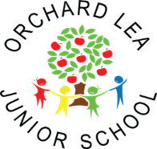
MFL Subject overview

 | Year 3 | Year 4 | Year 5 | Year 6
Autumn | Introduction to French  Colours | Days/ months/ seasons  Weather | Dates and times  Sports | Likes and dislikes/ Hobbies  Daily routine
Spring | Classroom objects  Food | Transport  Pocket money | The town and directions | Au restaurant  School
Summer | Family  Pets | Animals  We’re going on a Bear Hunt | Food and drink  Tour de France | My house  La Francophonie
Updated September 2018

